**Experiment No.: 8 Date: 21-03-2023**

**AIM**: Familiarization of linux commands.

**CO2**: Perform system administration task.

1. Ip addr :

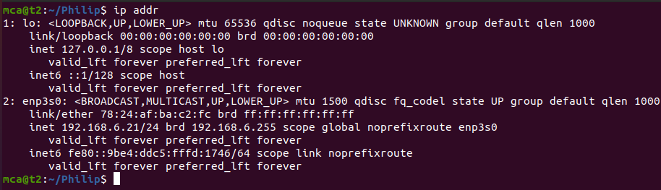

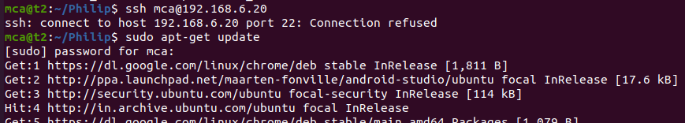

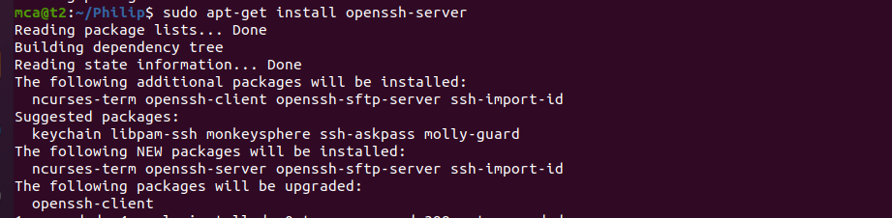



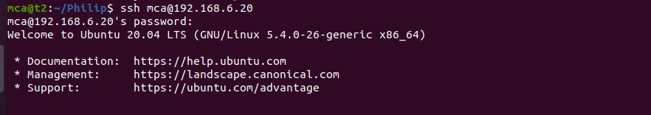

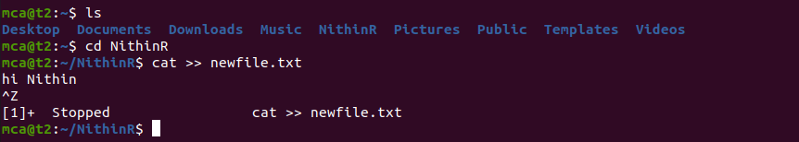

Ssh stands for secure shell

Ssh-keygen : generate a key for ssh

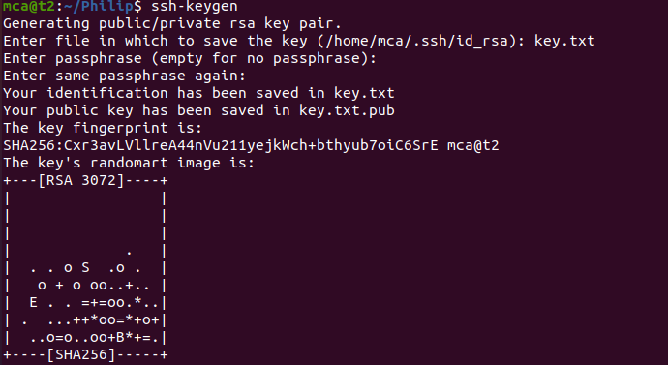

Ps : currently running program

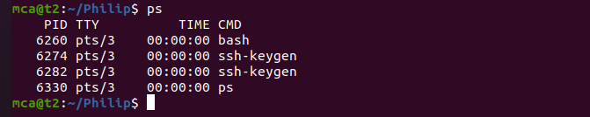

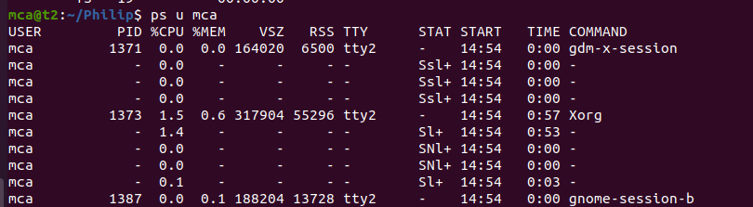

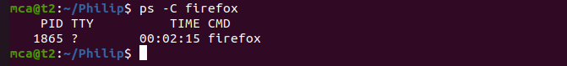



**Result**

The program was executed and the result was successfully obtained. Thus CO2 was obtained